EXPERIMENT-7
IMPLEMENTATION OF 2DES
AIM:
To implement Double DES (2DES) encryption and decryption using two different keys.
ALGORITHM
- Read the plaintext from the user.
- Read two keys, K1 and K2.
- Encrypt the plaintext using K1.
- Encrypt the result again using K2.
- Display the encrypted text in hexadecimal format.
- Decrypt the ciphertext using K2.
- Decrypt the result again using K1.
- Display the original plaintext.
Encryption:
C = E(K2, E(K1, P))
Decryption:
P = D(K1, D(K2, C))
CODE:
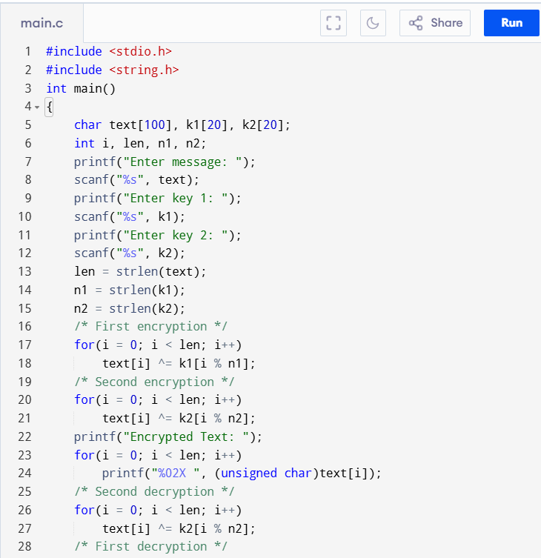
OUTPUT:
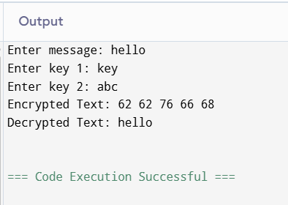
RESULT:
Thus, the Double DES (2DES) encryption and decryption process was successfully demonstrated using two keys.

